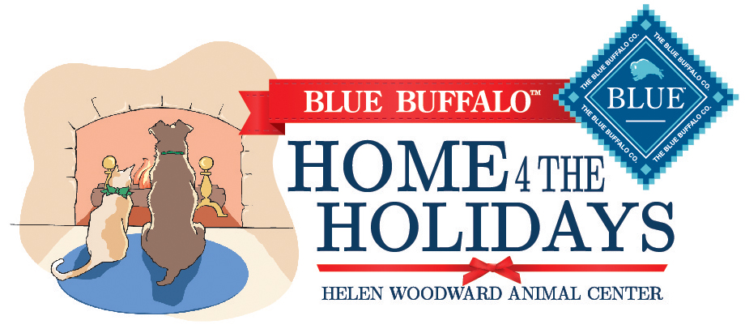

Celebrating Forever Homes

As makers of one of the finest natural pet foods, we at Blue Buffalo® know that a loving home is as important as wholesome nutrition for dogs and cats to live long, happy lives. **That’s why we’re proud to continue our partnership with the Helen Woodward Animal Center and our support of the Home 4 the Holidays pet adoption drive campaign.**

Free adoption kits

At Blue Buffalo, we’re committed to helping pets get their second chance at a loving forever home, which is why **we’re providing free adoption kits* and materials to help get these pets off to a healthy new start.**

**In each adoption kit you will find:**

* Sample of BLUE™ 100% natural pet food
* $3 off coupon to save on BLUE dry food purchase and additional offers
* Helpful informational brochure
* Pet photo magnet

*\*Available to all participating shelters in the U.S., Canada and Puerto Rico, while supplies last.*

To learn more about BLUE and to find a retailer near you please visit [BlueBuffalo.com](http://www.bluebuffalo.com).

Love them like family. Feed them like family.®